# Explanation About the slide1.pdf

1. Use first picture for the slider exactly like it is.



1. Use the second picture for the slider exactly like it is, just make some changes in selected areas:

**Prestashop** change to: **CMS**

**Danashop** change to: **SocialTime**

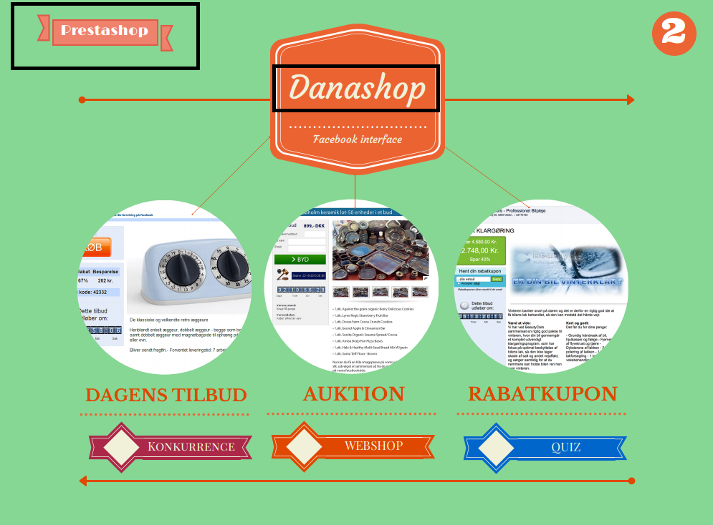

1. On the last slide make some more changes:

* **ONTODAY** change to **SocialTime**
* Make screenshot of our prices from this page: <http://new.socialtime.dk/prisliste-2/> and put it instead of existing one.
* Remove the last line

